Making an Appeal / Referral to the Labour Court.
If you are involved in a complaint or a dispute related to your workplace, whether you are an employer or an employee, the State provides, through the WRC and the Labour Court, dispute resolution mechanisms which may help you to resolve workplace issues.
When should you make an appeal or seek a referral to the Labour Court? Link

How to make an appeal/referral to the Labour Court.
To make an appeal/referral to the Labour Court, please use our Portal: Link
If you have persistent issues with using the portal, you may submit an appeal/referral using these alternative methods.
- By email to info@labourcourt.ie
- Through the post to The Programming Unit, The Labour Court, Lansdowne House, Lansdowne Road, Dublin 4, D04 A3A8.
The relevant forms can be found here: Link

Guide to Using the Portal.
The Portal is an easy and efficient way of making an appeal or a referral to the Labour Court.
You should have this guide open as you use the Portal to take you through each Section.
The home page of the Portal has three boxes as show below:
- If you wish to appeal the decision of an Adjudication Officer of the WRC, you must click on the first box.
- If you wish to make a referral under Industrial Relations Legislation, you must click on the centre box.
- For information on Registering an REA or Collective Agreement, or requesting an examination leading to a possible SEO, please refer to the website. Manual applications will still be required for these types of applications/requests.

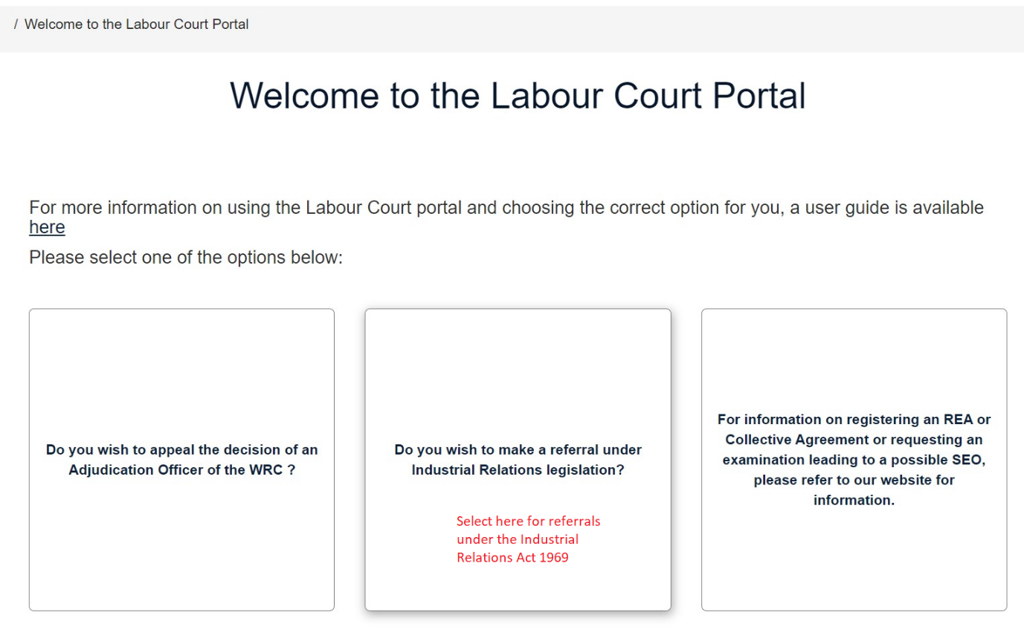

If you wish to appeal the decision of an Adjudication Officer of the WRC,
Click on the first box.

Providing Details of the Adjudication Decision.
You must provide the details of the Adjudication Decision that you are appealing. You will be asked for the details of the decision you received from the Adjudication Officer of the WRC so you must have this at hand. You will be asked to enter the ADJ number and the date of the decision.
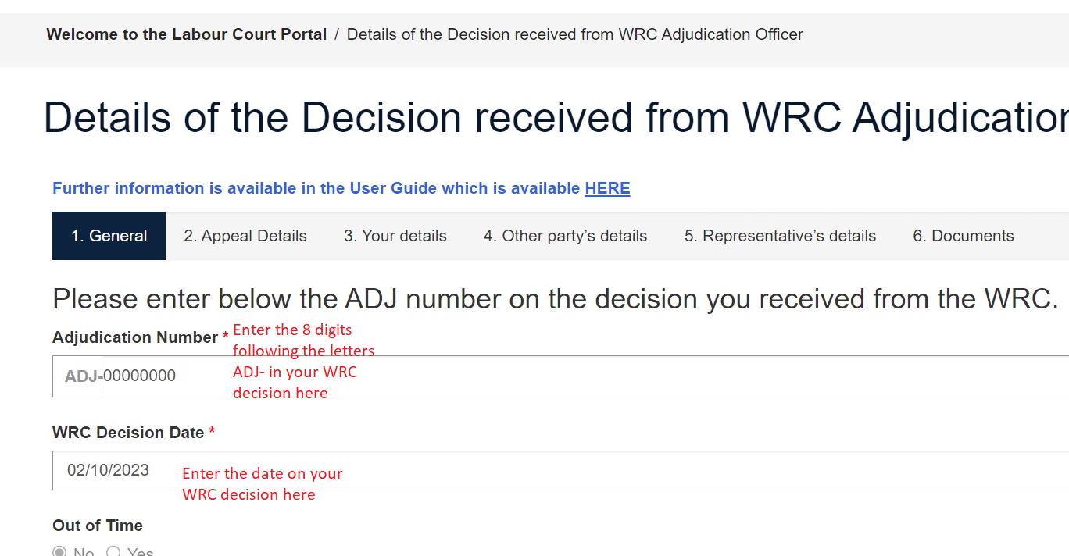

Out of time.
The Labour Court cannot hear Appeals that are submitted more than 42 days from the date of the decision being appealed unless it determines that exceptional circumstances exist. If your Appeal falls outside the 42 day deadline and you intend to apply for an extension of time allowed by Section 44(4) of the Workplace Relations Act, 2015 based on the existence of exceptional circumstances, you will be required to include in your written submission your reason/s for your application for an extension of time.
Once you have entered the Adjudication Decision number and the date of the decision you should then click on ‘Next’.

Details of the Complaints you wish to appeal.
Enter the details of the Complaint no. you wish to appeal.
You must enter the CA no. that you wish to appeal and the relevant legislation and click next.
If you wish to appeal more than one complaint, click on enter complaint again and provide CA no. and legislation for each complaint of the Adjudication number that you wish to appeal.
When you have entered the detail of all the CA numbers you wish to appeal, then click next.

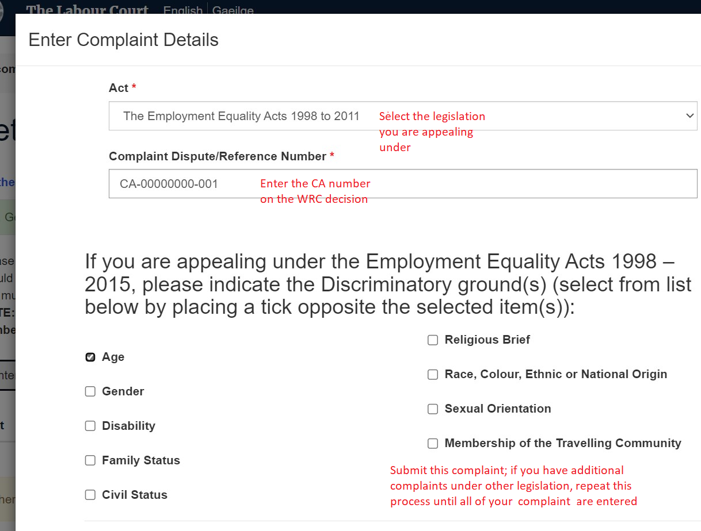

Enter the Party Details.
Please provide your details. The person appealing will be known as the appellant.
Please provide the details of the other party. The other party will be known as the respondent.
Where a party is a company, the Address of the Company must be the Registered Office/Place of Business/Principal Office Address’.
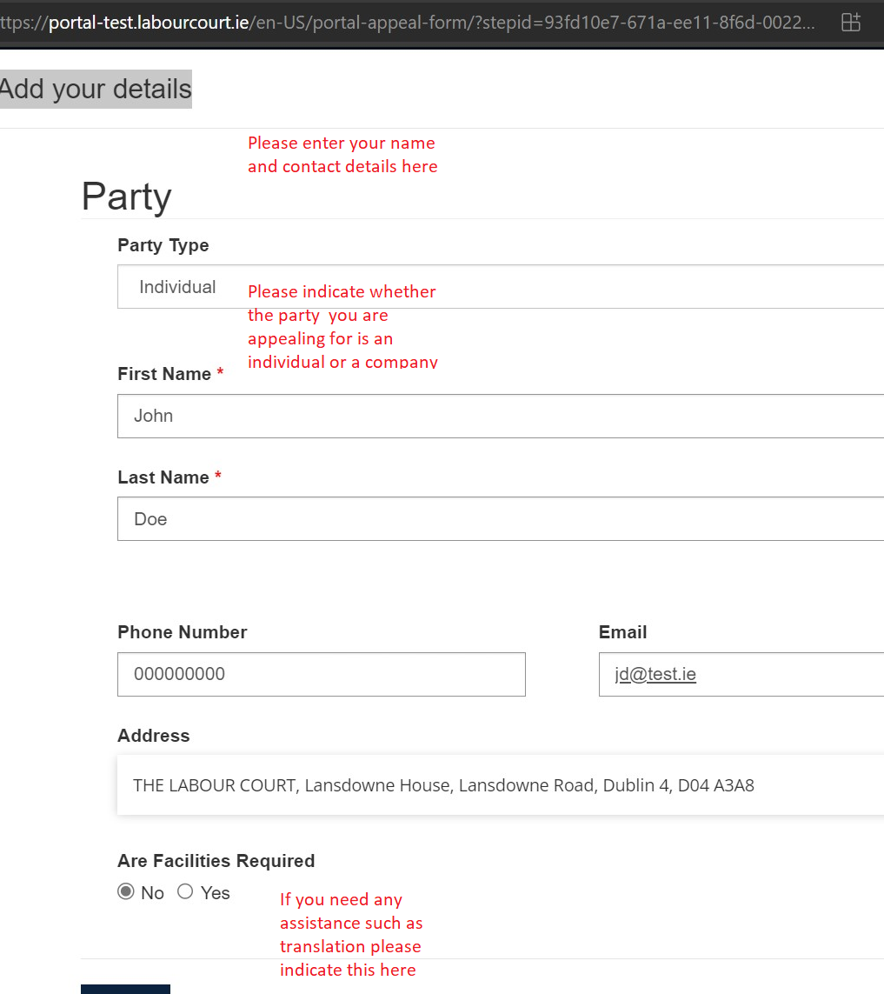
Please provide the name of your representative if this is relevant. You should also provide the details of the representative of the other party if that is available to you.
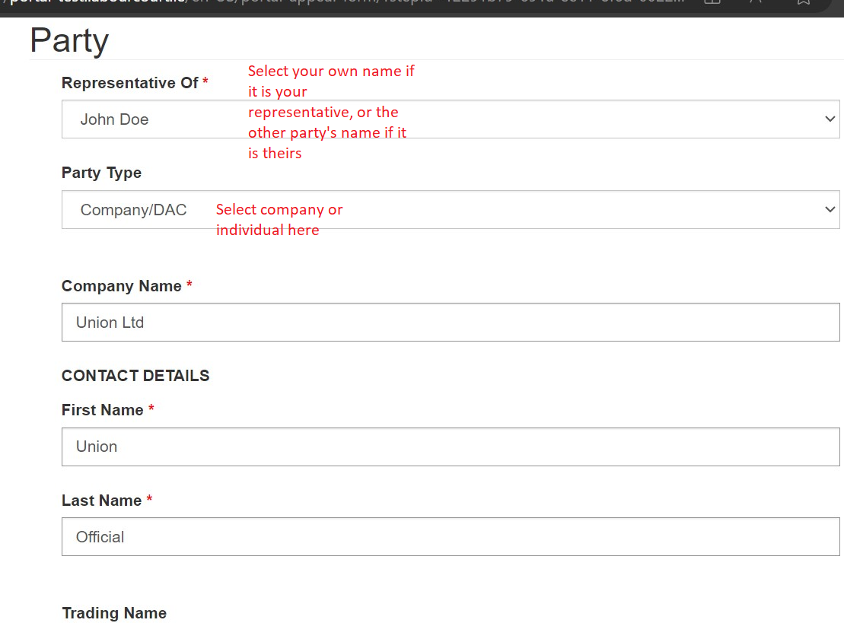
If you do not have a representative and the other party does not have a representative or the representative is not known to you, click next.

Upload a document.
You must upload a copy of the Decision of the Adjudication Officer. Click on upload and choose your document.
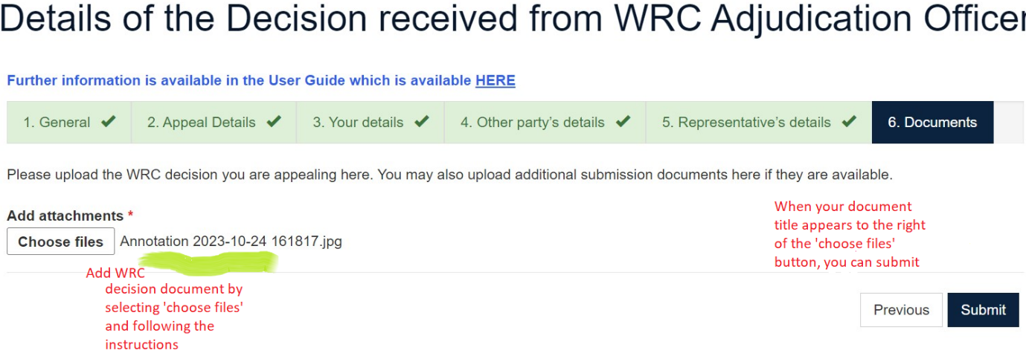

Once you press submit, you will receive an LC number as shown below.
Please keep this appeal number as your reference number.
You will also receive an email which will provide confirmation of your appeal.
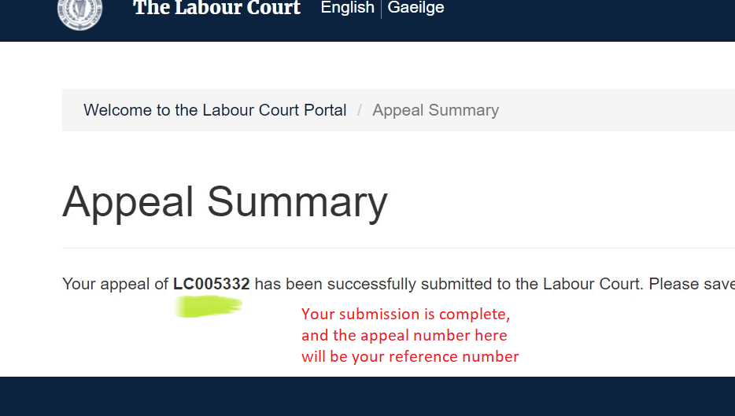

Do you wish to make a Referral under Industrial Relations legislation?

If so, click on the centre box:

Do you wish to make a referral under Section 20(1) or Section 20(2), please select the relevant box.
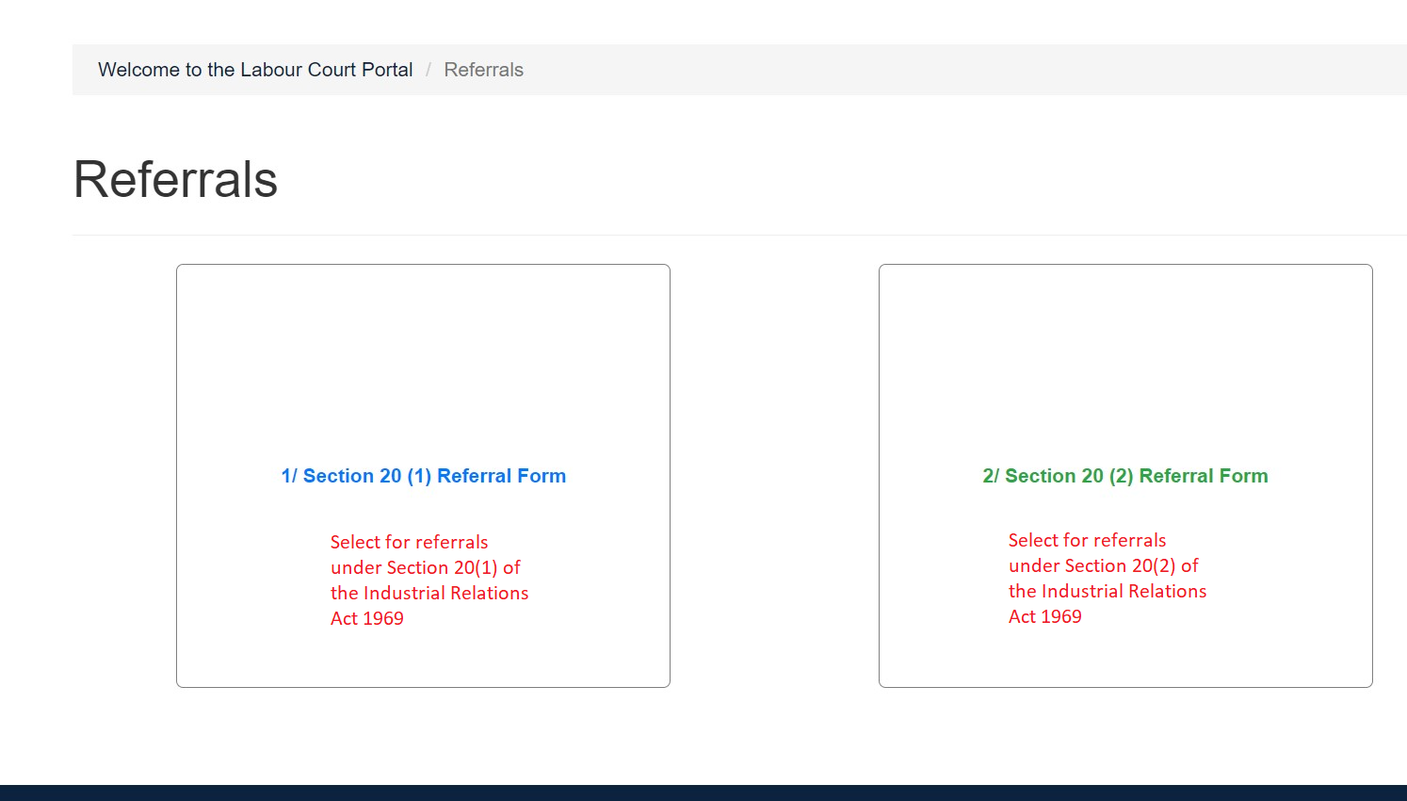

Referral under Section 20(1)
You must provide details of the Referral
You must provide details of redress sought
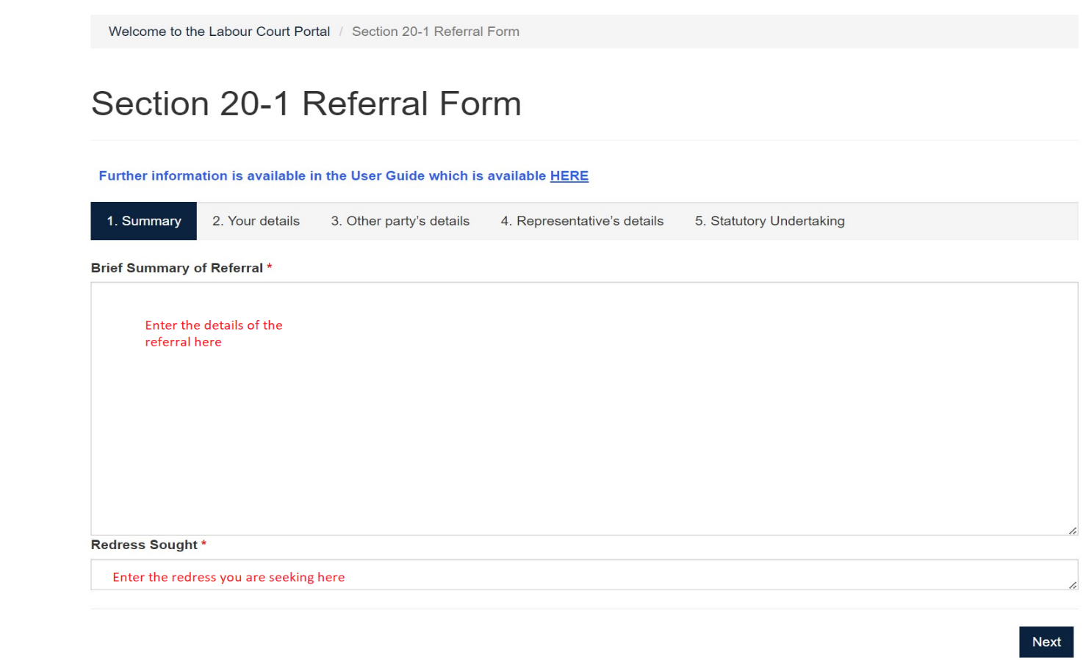
Please provide your details and the details of the other party.
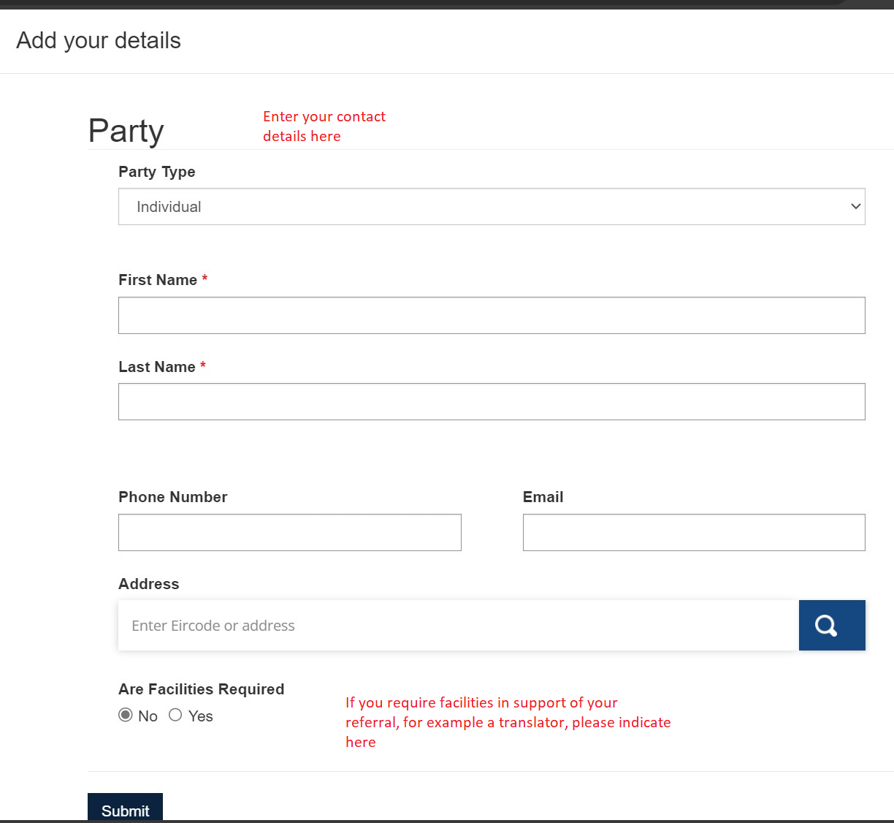

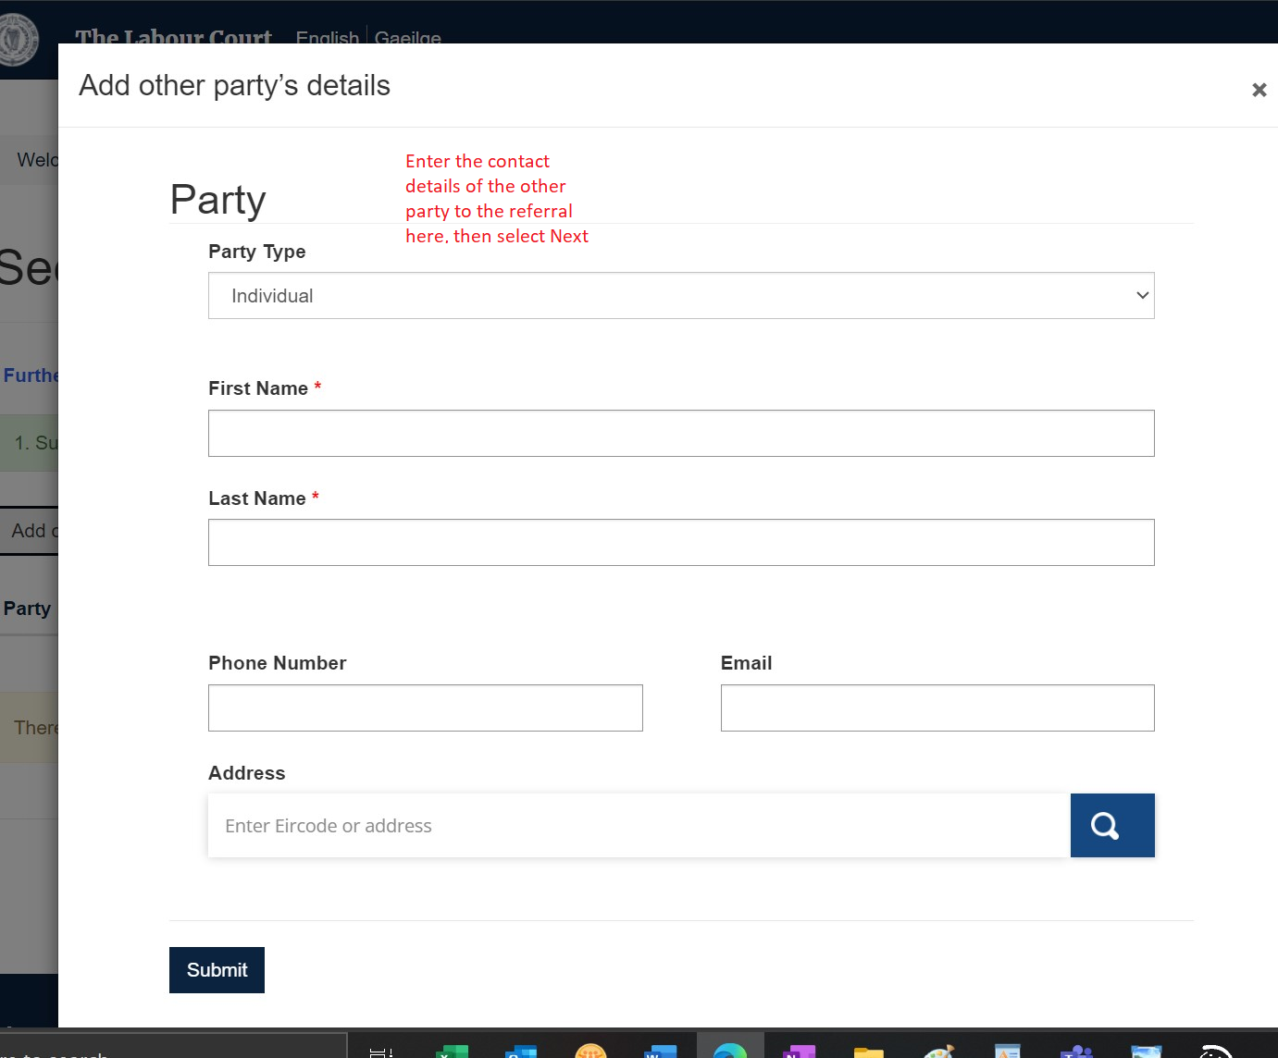
Please provide the details of your representative if this is applicable.
You should also provide the details of the representative of the other party if this is available to you.
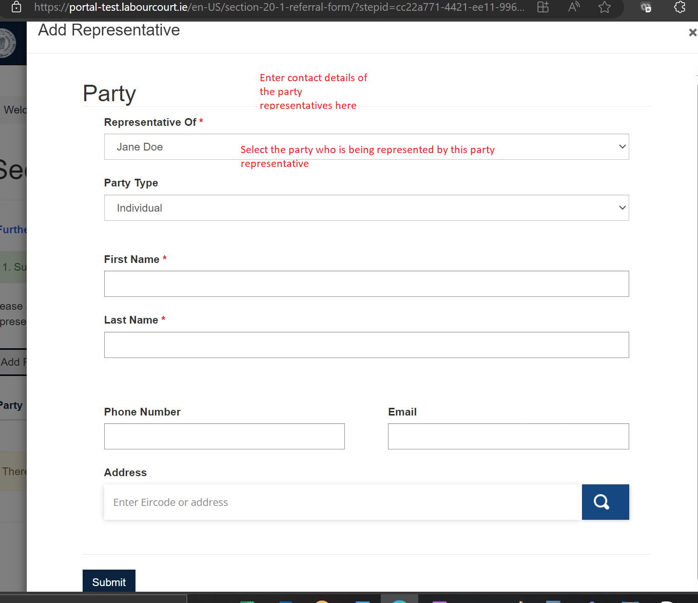
A worker in a trade dispute, or a trade union on their behalf, may directly refer a case to the Labour Court under Section 20(1) of the Industrial Relations Act, 1969, on condition that the worker agrees in advance to accept the Labour Court’s Recommendation.
By selecting the submit button, you are declaring that you agree to be bound by the recommendation of the Labour Court.
Once you press submit, you will receive an LC number as shown below.
Please keep this appeal number as your reference number.
You will also receive an email which will provide confirmation of your appeal.

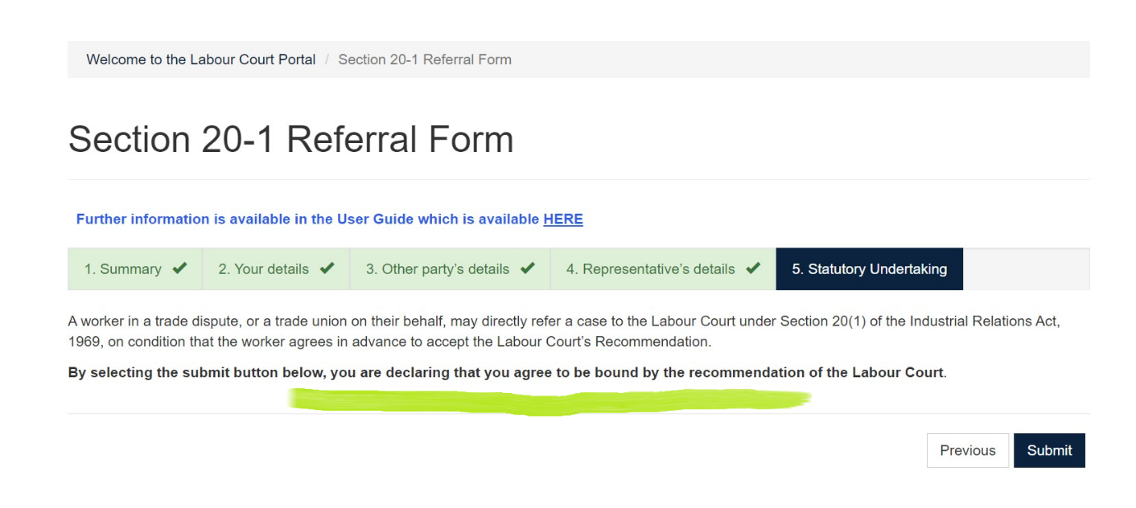

Referral under Section 20(2)
You must provide details of the Referral
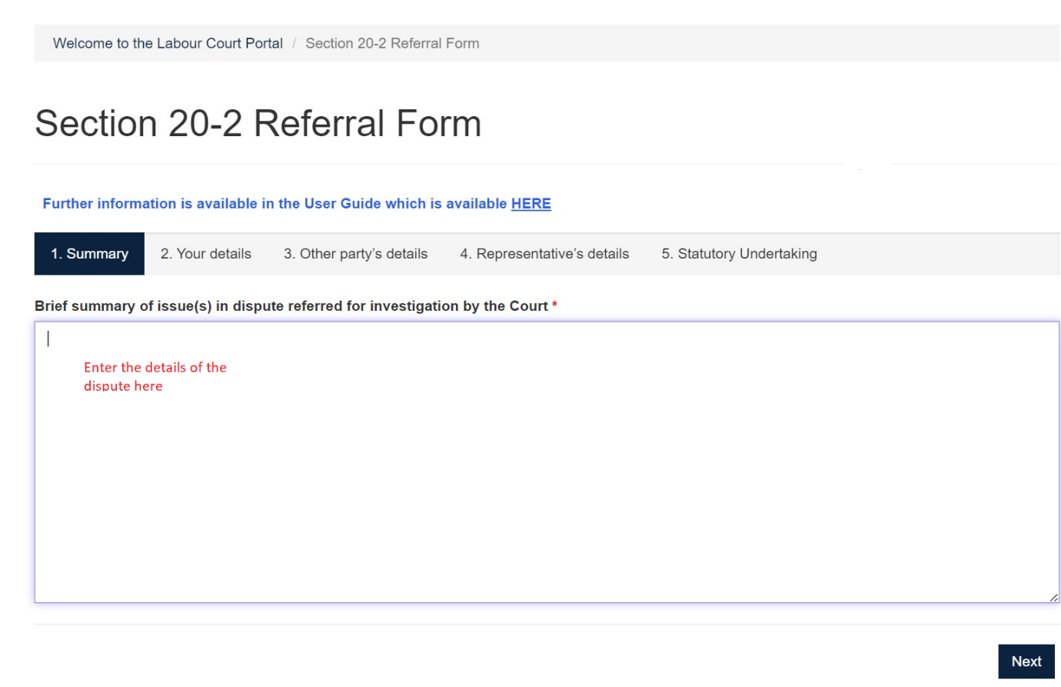
Please provide details of both parties.
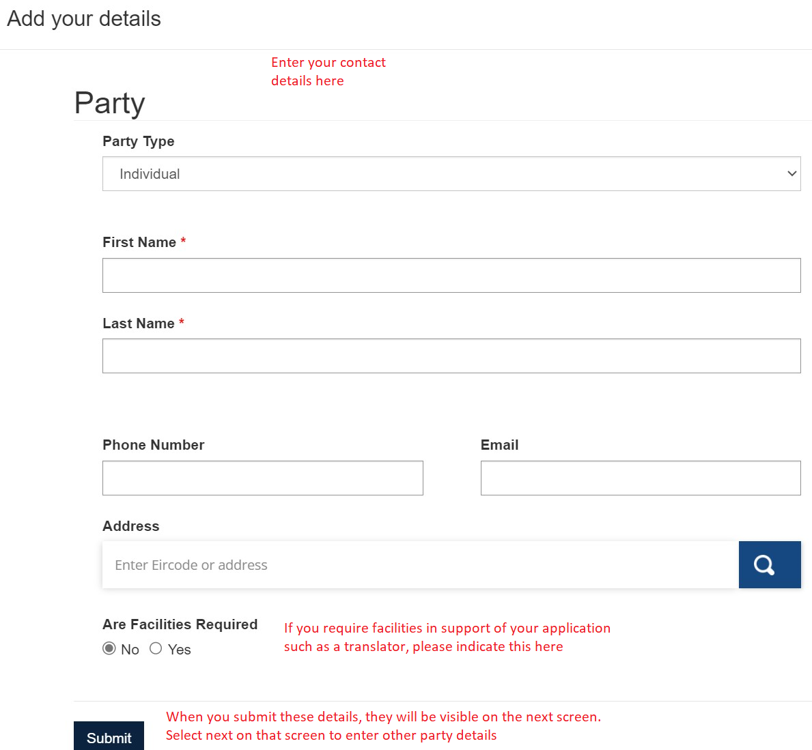

Please provide details of the other party
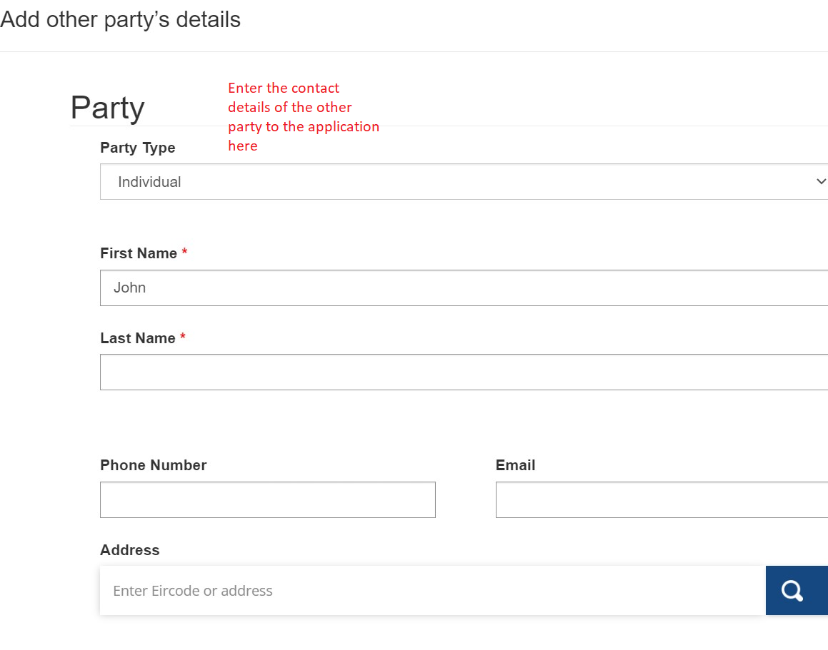
Please provide the details of your representative if this is applicable.
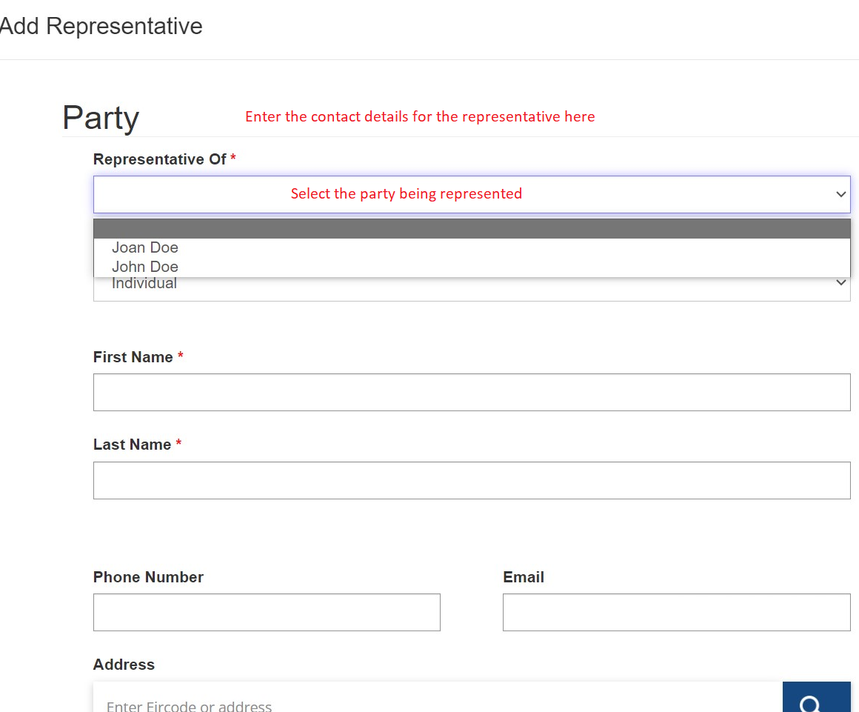
You should also provide the details of the representative of the other party if this is available to you.

All referrals to the Labour Court under Section 20(2) require the appellants to confirm that they agree to be bound by the recommendation of the Court. This is a statutory undertaking which is confirmed/binding when the appellant signs the hard copy form.
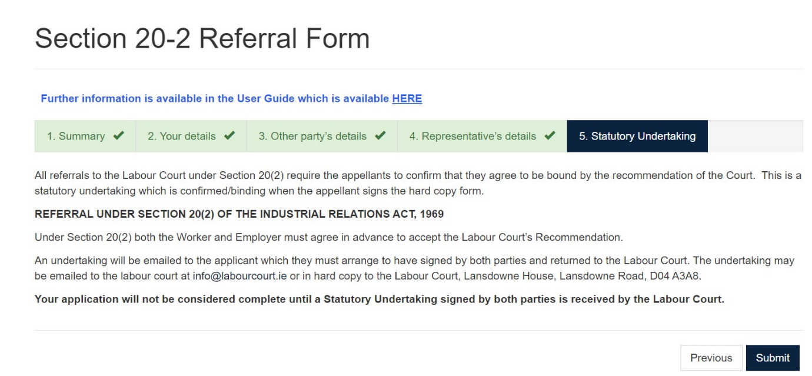
The applicant must print down the Statutory Declaration and arrange for it to be signed by both parties and either email the signed copy to info@labourcourt.ie or send by post to Lansdowne House, Lansdowne Road, Dublin 4

