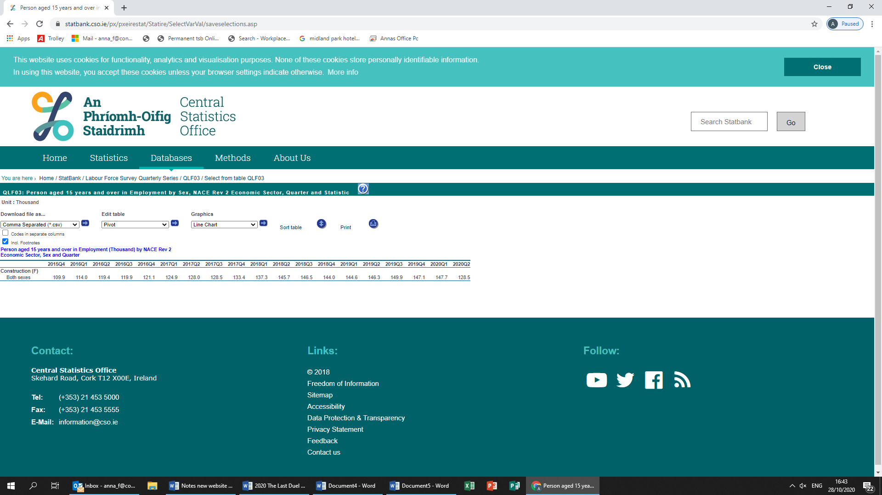

**Formula 2:** How to calculate CPI Increase

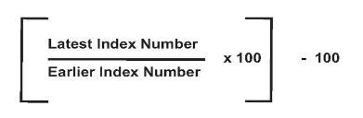

**i.e. it is figure of 128.5 divided by 109.9 x 100 and then less 100 equals to approximately 17%**